Notes:
1.Question 2 ,5 is compulsory

1.

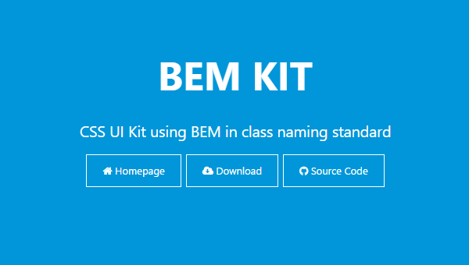

2.

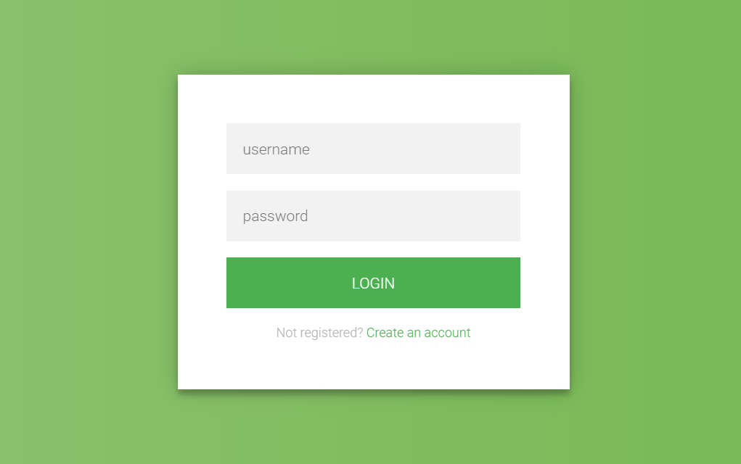

3. For background add more css property :
background-repeat:norepeat
background-size:cover

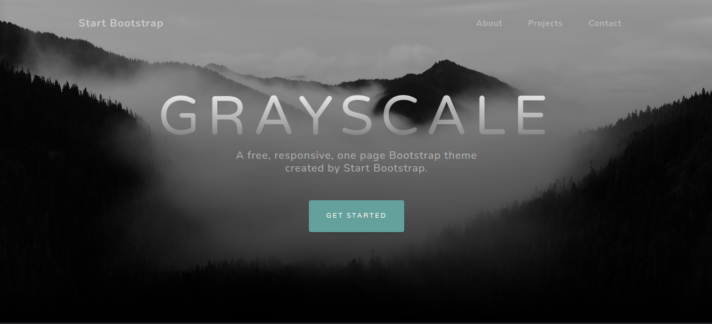

4.

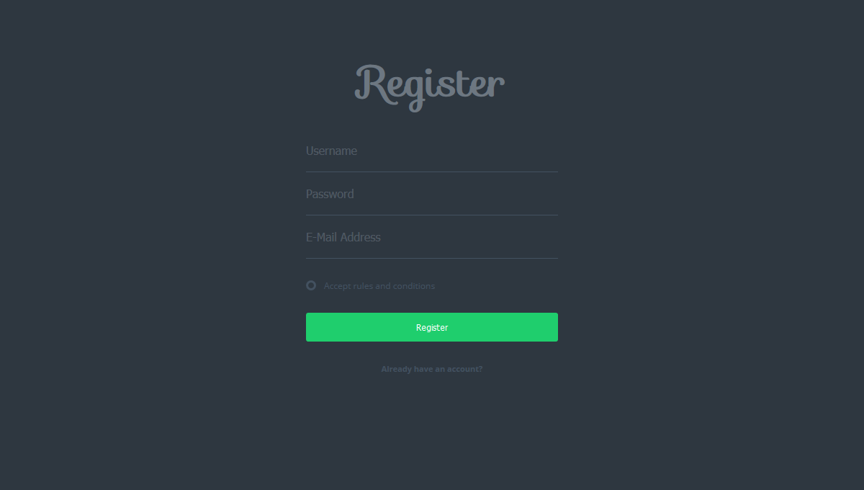

5. Use any icon (No need to use the same icon). (Do not use any logo,just use text “Shades” )

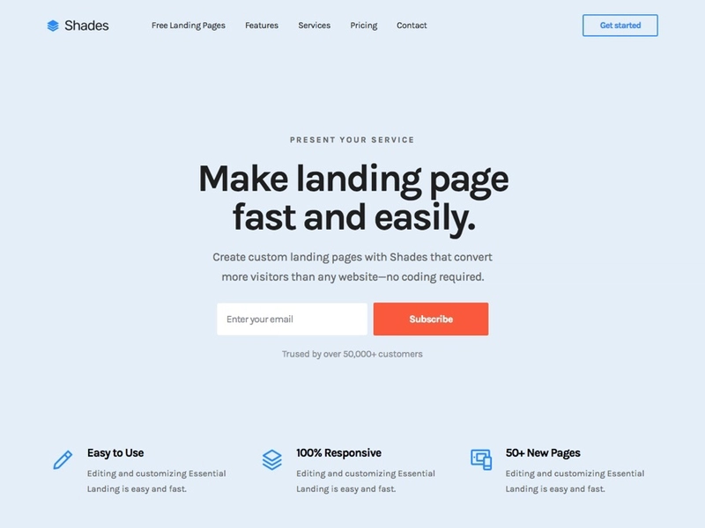

6. Complete the Website in the link.
Note: To create gradient effect of side menu use below css(change color accordingly):
background: linear-gradient(to top, #000d8f 0%, #1C6EA4 50%);

https://www.html.am/templates/downloads/bryantsmith/slickblue/#

